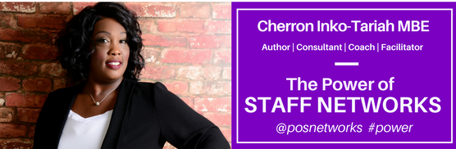
Speaker Booking Form
Thank you for considering us for your event. To help ensure that we meet your needs, please complete the form below.
Contact Name
Name of organisation and event
Phone
Email
Date and timings of event
Event location
Speaking Topic
Type of presentation
Length of presentation time
Size & audience description
Expectations? What do they want to learn/take away from this session?
A/V Equipment available?
Will you film /take photos at the event?
If yes, can we have copies please.
Vendor table available for book/product sales?
Interested in purchasing books for audience ahead of the event?
Will your organisation handle any hotel and travel arrangements?
Onsite event contact name and mobile phone number?
Internet access available? Hashtag?
Other info?

