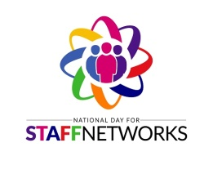
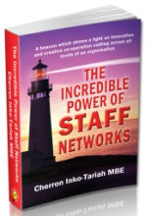
Speaker Booking Form
Thank you for considering us to speak at your event. To help ensure that we meet your needs, please complete the form below.

Contact Name
Name of company or event
Phone
Email
Date and time of event
Event location
Speaking Topic
Length of presentation time
Audience size
Describe the audience
Expectations? What do they want to learn/take away from this session?
A/V Equipment available?
Will you film /take photos at the event?
If yes, can we have copies please.
Internet access available?
Vendor table available for book/product sales?
Interested in purchasing books for audience ahead of the event?
What is your budget to cover fees and travel expenses?
Will your organisation handle the travel arrangements?
Onsite event contact name and mobile phone number?
Hashtag for the event?
Other info?

